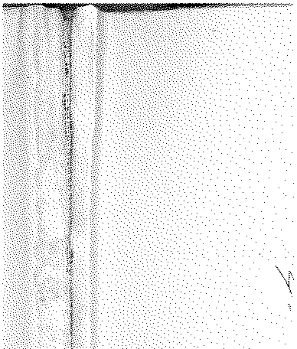

# Annual Vol ume of

TH E LAW S



# of Western N igeria

1962

## containin g

the Laws of Western Nigeria

and subsidiary legisla tion made thereunder



LOS ANGELES COUNTY

LAW LIBRARY

### B 467

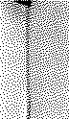

Supplement to Western Nigeria Gazette No. 691 Vol. 11, 6th September, 1962-Part B

**W.N.L.N. 252 of 1962**

### The Local Government Law (Cap. 68)

THE CONTROL OF DRUMMING ADOPTIVE BYE-LAWS, 1956 AJEROMI DISTRICT COlJNCIL

DATE OF COMMENCEMENT : 6TH SEPTEMBER, 1962

Notice is hereby given that in exercise_ of the powers conferred upon the Ajeromi District Council by sections 83 *(a)* and 276 of the Local Government

Law Cap. 68, the Ajeromi District Council in accordance with section 83 (3)

1

of the said Law has resolved at its meeting held on the 11thday of August, 1962 that the Control of Drumming Adoptive Bye-laws, 1956 as amended by the Control of Drumming Adoptive Bye-Jaws (Amendment) Order, 1957, be adopted, substituting the following for the First and Third Schedules thereto:-

FIRST SCHEDULE

Sakara Ahia Ayo Ogene

Iya Ilu or Dundun Ekwe Ogele Obia Batakoto Ngelenge Opi Ogwe

Apala/Juju Uyara Ubah Oyo Kete or Agasa Shaka Igbomu Ngenege Ukere Okiri Uze Eyele

Iyegume Akwa Otogwemi Agba

Nkoro Kpokpo Oji Ishaka

Asakasaka Agogo Akpele Esie

Agugu Opuoje Agbele Nkwa

Ukela Agbarangha Kenemukenemu

Degedegekiri Mpetere Asumata

THIRD SCHEDULE

*Description of Drum Period Fees*

*s d*

Sakara For any period between 6 a.m. and 6 p.m. 6 0

For aoy period between 6 p.m. and 6 a.m. 11 0 Iya Ilu or Dundun For any period between 6 a.m. and 6 p.m. 6 0

*F* For any period between 6 p.m. and 6 a.m. 11 0

Batakoto ... For any period between 6 a.m. and 6 p.m. 6 0

For aoy period between 6 p.m. and 6 a.m. 11 0

Apala/Juju For any period between 6 a.m. aod 6 p.m. 6 0 For any period between 6 p.m. and 6 a.m. II 0

Kete or Agasa For any period between 6 a.m. and 6 p.m. 6 0

For any period between 6 p.m. and 6 a.m. 11 0

Ukere For any period between 6 a.m. and 6 p.m. 6 0

For any period between 6 p.m. and 6 a.m. 11 0

Iyeyume For any period between 6 a.m. and 6 p.m. 6 0

For any period between 6 p.m. and 6 a.m. 11 0

Nkoro For any period between 6 a.m. and 6 p.m. 6 0

For any period between 6 p.m. and 6 a.m. ... 11 0

W.RL.N. 1

of 1956. W.R.L.N. 297 of l 957.